Partial / residual correlation: EURUSD and AUDUSD
Method 07 / daily log returns / leave-currency-out USD factor / Alpari D1 full available history

Study setup
Logical pair: EURUSD , AUDUSD
Broker symbols: EURUSD_i , AUDUSD_i
Snapshot: 2026-11-03_majors_alpari_D1
Timeframe: D1
Matched return window: 1999-01-05 to 2026-11-02 (UTC bar dates)
Matched return count n: 7148
Dropped unfinished last bar dated 2026-11-03 UTC after a tick-volume check against the prior complete day.
USD-strength sign rule: minus log return when USD is the quote (EURUSD, GBPUSD, AUDUSD, NZDUSD); plus log return when USD is the base (USDJPY, USDCHF, USDCAD). EURGBP is never a constituent.
Control z constituents (5): GBPUSD, NZDUSD, USDJPY, USDCHF, USDCAD
z_t = equal-weight mean of those USD-strength returns on the same day
Complete matched rows (Excel): EURUSD-AUDUSD_Partial_D1.xlsx
Complete matched rows (HTML table): EURUSD-AUDUSD_Partial_D1_data.html

Method carried forward
Partial / residual correlation regresses each matched daily log return of close, ln(close_t / close_t-1), on the same leave-currency-out USD strength factor z, then takes Pearson correlation of the two residual series. Quotes are not inverted. z is the equal-weight mean of USD-strength returns from other majors that do not share a non-USD currency with either leg; EURGBP is never a constituent. USD-strength is minus the log return when USD is the quote (EURUSD, GBPUSD, AUDUSD, NZDUSD) and plus the log return when USD is the base (USDJPY, USDCHF, USDCAD). OLS uses an intercept on each leg. rho_partial is symmetric under swap of the two symbols. It describes leftover linear co-movement after removing linear z; it is not a cause, not a lead, and not a trading signal. Daily rows are not independent and residuals are estimated, so the two-sided p-value and Fisher interval are secondary. Same-sample raw Pearson r is a side check only.

Regression on z
leg | intercept_a_or_c | slope_b_or_d | R2
EURUSD | -8.03e-06 | -1.0376519 | 0.607662
AUDUSD | 2.449e-05 | -1.2536098 | 0.52362342

Results
rho_partial: -0.015950
Two-sided p-value: 0.177553
Approximate 95% Fisher interval: [-0.039118, 0.007236]
Same-sample raw Pearson r: 0.557184
rho_partial minus r: -0.573134

Conclusion
Over 7148 matched daily rows for EURUSD and AUDUSD after removing a leave-currency-out USD factor built from 5 constituents, rho_partial is -0.0159 (negative, weak residual linear link in this sample). Approximate 95% Fisher interval: [-0.0391, 0.0072]. Same-sample raw Pearson r is 0.5572 (partial minus r = -0.5731). Leg R-squared on z: EURUSD=0.6077, AUDUSD=0.5236. Two-sided p under the usual independent-pairs model is 0.1776; residuals are estimated and daily FX rows are linked, so treat p as secondary. This does not establish cause, lead-lag, or a lasting trading rule.

Charts
Daily closes
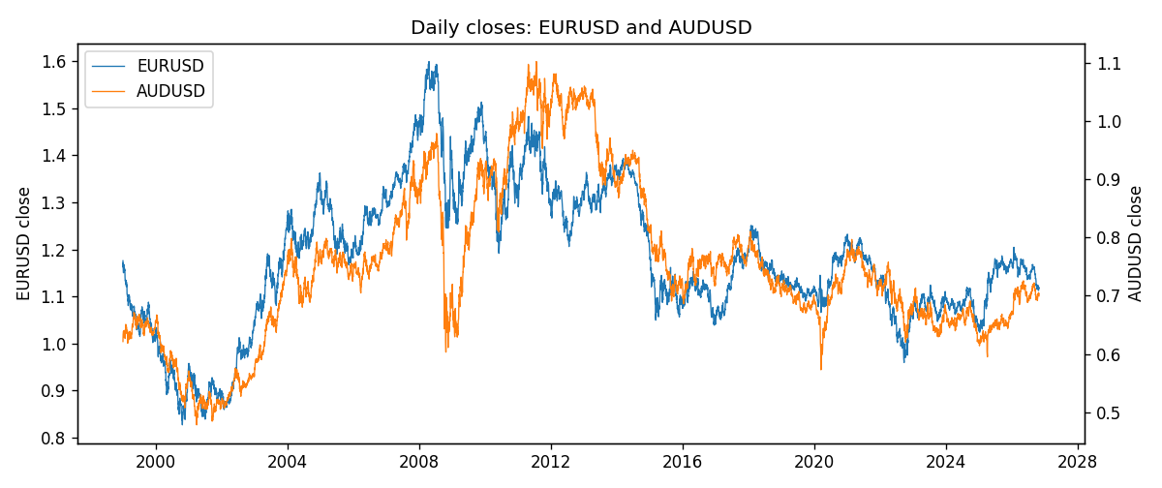
Log returns and control z
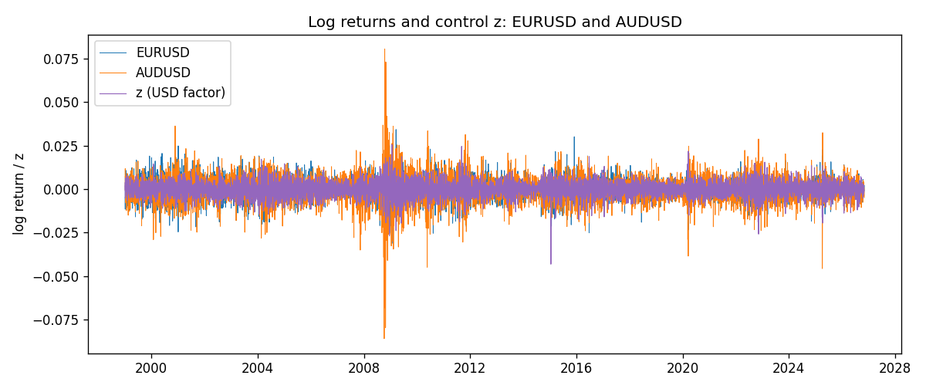
Residual scatter e_x vs e_y
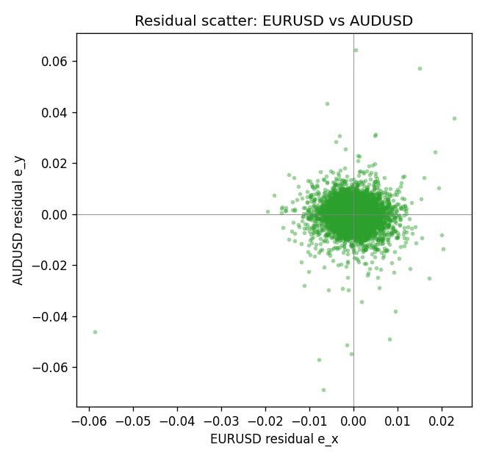

Data report
Every matched row that entered the partial correlation is stored in the sibling Excel workbook named EURUSD-AUDUSD_Partial_D1.xlsx. That file is the complete data archive for redrawing charts. Embedding all rows as a Word table is impractical at this length; the Word file holds the column list, column summaries, and the first and last 15 matched rows.
Columns: time, EURUSD_open, AUDUSD_open, EURUSD_high, AUDUSD_high, EURUSD_low, AUDUSD_low, EURUSD_close, AUDUSD_close, EURUSD_tick_volume, AUDUSD_tick_volume, EURUSD_spread, AUDUSD_spread, EURUSD_real_volume, AUDUSD_real_volume, EURUSD_log_return, AUDUSD_log_return, usd_strength_GBPUSD, usd_strength_NZDUSD, usd_strength_USDJPY, usd_strength_USDCHF, usd_strength_USDCAD, z, EURUSD_fitted, AUDUSD_fitted, EURUSD_resid, AUDUSD_resid
Column summaries (matched calculation rows)
column | count | mean | std | min | 25% | 50% | 75% | max
EURUSD_open | 7148 | 1.1816879 | 0.15074041 | 0.8272 | 1.0863875 | 1.16609 | 1.2942 | 1.5995
AUDUSD_open | 7148 | 0.75254463 | 0.13531821 | 0.4785 | 0.661255 | 0.7317 | 0.812135 | 1.10284
EURUSD_high | 7148 | 1.1868219 | 0.15134312 | 0.8326 | 1.0904675 | 1.17121 | 1.29957 | 1.6038
AUDUSD_high | 7148 | 0.75660194 | 0.1358782 | 0.4878 | 0.6652025 | 0.7351 | 0.8182725 | 1.10795
EURUSD_low | 7148 | 1.1766784 | 0.15005373 | 0.8227 | 1.0822025 | 1.162475 | 1.2886225 | 1.5865
AUDUSD_low | 7148 | 0.74848743 | 0.13462984 | 0.4775 | 0.65803 | 0.727775 | 0.80652 | 1.0975
EURUSD_close | 7148 | 1.1817317 | 0.15070664 | 0.8267 | 1.0862225 | 1.16602 | 1.2942 | 1.5997
AUDUSD_close | 7148 | 0.75259994 | 0.13529833 | 0.4786 | 0.6614925 | 0.7318 | 0.81193 | 1.10169
EURUSD_tick_volume | 7148 | 103711.54 | 173856.26 | 469 | 9484.75 | 52998 | 99801.75 | 1471626
AUDUSD_tick_volume | 7148 | 77889.255 | 138502.92 | 109 | 5574 | 43696 | 71619 | 1234623
EURUSD_spread | 7148 | 19.246223 | 16.509774 | 0 | 8 | 12 | 20 | 50
AUDUSD_spread | 7148 | 30.707051 | 16.89031 | 0 | 13 | 30 | 50 | 50
EURUSD_real_volume | 7148 | 4.0536992e+10 | 1.6733469e+11 | 0 | 0 | 0 | 0 | 3.6149665e+12
AUDUSD_real_volume | 7148 | 5.2809589e+09 | 1.2584371e+11 | 0 | 0 | 0 | 0 | 3.811512e+12
EURUSD_log_return | 7148 | -2.16e-06 | 0.0058013 | -0.03123819 | -0.00324218 | 0 | 0.00325609 | 0.03433183
AUDUSD_log_return | 7148 | 3.157e-05 | 0.00755018 | -0.08602525 | -0.00385014 | 0.00029168 | 0.00415111 | 0.0806166
usd_strength_GBPUSD | 7148 | 1.992e-05 | 0.00564699 | -0.03112653 | -0.00318167 | -3.426e-05 | 0.0031217 | 0.08388241
usd_strength_NZDUSD | 7148 | -1.914e-05 | 0.00764519 | -0.05966839 | -0.004586 | -0.00023666 | 0.00424201 | 0.07027433
usd_strength_USDJPY | 7148 | 5.267e-05 | 0.00620906 | -0.03908203 | -0.00319392 | 0.00012736 | 0.00340928 | 0.05184024
usd_strength_USDCHF | 7148 | -6.945e-05 | 0.0065937 | -0.19545699 | -0.00334697 | 8.15e-05 | 0.00331954 | 0.09051364
usd_strength_USDCAD | 7148 | -1.226e-05 | 0.00514518 | -0.03859748 | -0.00283513 | 4.873e-05 | 0.00272781 | 0.03436319
z | 7148 | -5.65e-06 | 0.00435817 | -0.04315297 | -0.0024853 | 1.624e-05 | 0.00249882 | 0.02568604
EURUSD_fitted | 7148 | -2.16e-06 | 0.00452227 | -0.0266612 | -0.00260093 | -2.489e-05 | 0.00257084 | 0.04476973
AUDUSD_fitted | 7148 | 3.157e-05 | 0.00546345 | -0.03217579 | -0.00310805 | 4.12e-06 | 0.00314008 | 0.05412147
EURUSD_resid | 7148 | -0 | 0.00363375 | -0.05871117 | -0.00198513 | 1.292e-05 | 0.00195332 | 0.02278542
AUDUSD_resid | 7148 | 0 | 0.00521114 | -0.06871524 | -0.0024266 | 0.00016917 | 0.00263431 | 0.06438206
First 15 matched rows (selected columns)
time | EURUSD_close | AUDUSD_close | EURUSD_log_return | AUDUSD_log_return | z | EURUSD_fitted | AUDUSD_fitted | EURUSD_resid | AUDUSD_resid
1999-01-05 | 1.1758 | 0.6215 | -0.0048360507 | -0.00080418179 | -0.00032229443 | 0.00032639904 | 0.00042851732 | -0.0051624497 | -0.0012326991
1999-01-06 | 1.1623 | 0.6289 | -0.011547966 | 0.011836351 | 0.0038799904 | -0.0040341097 | -0.004839508 | -0.0075138566 | 0.016675859
1999-01-07 | 1.1712 | 0.6345 | 0.0076280636 | 0.0088650256 | -0.0049794731 | 0.0051589292 | 0.0062668021 | 0.0024691343 | 0.0025982235
1999-01-08 | 1.1585 | 0.6347 | -0.010902799 | 0.00031515916 | 0.0021336287 | -0.0022219942 | -0.002650252 | -0.0086808051 | 0.0029654111
1999-01-11 | 1.1503 | 0.6393 | -0.007103287 | 0.0072213815 | -0.0038036345 | 0.0039388181 | 0.0047927593 | -0.011042105 | 0.0024286222
1999-01-12 | 1.1555 | 0.6362 | 0.0045103728 | -0.0048608485 | 0.006430465 | -0.0066806144 | -0.0080368079 | 0.011190987 | 0.0031759594
1999-01-13 | 1.1681 | 0.6312 | 0.010845346 | -0.0078902098 | -0.00094783556 | 0.00097549297 | 0.0012127018 | 0.0098698535 | -0.0091029116
1999-01-14 | 1.1681 | 0.6295 | 0 | -0.002696916 | 0.00055200034 | -0.00058081457 | -0.00066750716 | 0.00058081457 | -0.0020294089
1999-01-15 | 1.1563 | 0.634 | -0.010153245 | 0.007123101 | 0.0040569631 | -0.0042177457 | -0.0050613627 | -0.0059354993 | 0.012184464
1999-01-18 | 1.1605 | 0.6346 | 0.0036256946 | 0.00094592471 | -0.00029321192 | 0.00029622152 | 0.00039205919 | 0.0033294731 | 0.00055386552
1999-01-19 | 1.1603 | 0.6392 | -0.00017235436 | 0.0072225153 | -0.0013360496 | 0.001378324 | 0.0016993707 | -0.0015506784 | 0.0055231446
1999-01-20 | 1.1566 | 0.64 | -0.0031939256 | 0.0012507819 | -0.00066013526 | 0.00067696021 | 0.00085203789 | -0.0038708858 | 0.00039874402
1999-01-21 | 1.1601 | 0.6405 | 0.0030215416 | 0.00078094498 | -0.0013707874 | 0.0014143697 | 0.0017429183 | 0.0016071719 | -0.00096197333
1999-01-22 | 1.1587 | 0.6327 | -0.0012075213 | -0.012252745 | 0.003595198 | -0.0037385943 | -0.0044824895 | 0.002531073 | -0.0077702557
1999-01-25 | 1.1552 | 0.6302 | -0.0030251979 | -0.0039591468 | -0.00034102944 | 0.00034583946 | 0.00045200371 | -0.0033710373 | -0.0044111505
Last 15 matched rows (selected columns)
time | EURUSD_close | AUDUSD_close | EURUSD_log_return | AUDUSD_log_return | z | EURUSD_fitted | AUDUSD_fitted | EURUSD_resid | AUDUSD_resid
2026-10-13 | 1.11965 | 0.69821 | 0.0037402957 | 0.0035007712 | -0.0034808917 | 0.0036039234 | 0.0043881657 | 0.00013637232 | -0.00088739453
2026-10-14 | 1.11545 | 0.69715 | -0.0037582255 | -0.0015193215 | 0.0026360448 | -0.0027433272 | -0.0032800856 | -0.0010148983 | 0.0017607642
2026-10-15 | 1.12172 | 0.69191 | 0.0056053107 | -0.0075447063 | -0.0053218482 | 0.0055141954 | 0.0066960068 | 9.1115239e-05 | -0.014240713
2026-10-16 | 1.12371 | 0.69426 | 0.0017724895 | 0.0033906408 | -0.0033888712 | 0.0035084381 | 0.0042728079 | -0.0017359487 | -0.00088216715
2026-10-19 | 1.12086 | 0.6978 | -0.0025394633 | 0.0050859986 | 0.0010209294 | -0.0010673997 | -0.0012553612 | -0.0014720636 | 0.0063413599
2026-10-20 | 1.12354 | 0.70022 | 0.0023881672 | 0.0034620426 | -0.0035803332 | 0.0037071091 | 0.0045128265 | -0.0013189418 | -0.0010507839
2026-10-21 | 1.12318 | 0.70275 | -0.00032046717 | 0.0036066384 | -0.0011831986 | 0.0012197179 | 0.0015077552 | -0.001540185 | 0.0020988832
2026-10-22 | 1.12139 | 0.70186 | -0.0015949606 | -0.0012672558 | -0.002589814 | 0.002679295 | 0.003271102 | -0.0042742556 | -0.0045383579
2026-10-23 | 1.11989 | 0.70353 | -0.001338521 | 0.0023765656 | 0.0010107165 | -0.0010568023 | -0.0012425583 | -0.00028171877 | 0.0036191239
2026-10-26 | 1.11735 | 0.70128 | -0.0022706559 | -0.0032032829 | 0.0022710473 | -0.0023645869 | -0.0028225212 | 9.3930968e-05 | -0.00038076168
2026-10-27 | 1.11272 | 0.70245 | -0.004152342 | 0.0016669876 | 0.0021084004 | -0.002195816 | -0.0026186255 | -0.001956526 | 0.0042856131
2026-10-28 | 1.1152 | 0.70533 | 0.0022262927 | 0.0040915541 | 0.00046845535 | -0.00049412396 | -0.00056277435 | 0.0027204167 | 0.0046543284
2026-10-29 | 1.11772 | 0.70245 | 0.0022571351 | -0.0040915541 | -0.001914584 | 0.0019786413 | 0.0024246271 | 0.00027849383 | -0.0065161812
2026-10-30 | 1.11644 | 0.70316 | -0.0011458446 | 0.0010102376 | -0.00058280265 | 0.00059671589 | 0.00075509297 | -0.0017425605 | 0.00025514466
2026-11-02 | 1.11881 | 0.69971 | 0.002120569 | -0.0049184984 | -0.0004775523 | 0.00048750266 | 0.0006231501 | 0.0016330663 | -0.0055416485

